Julian Burgoff

10/17/22

Analysis of Environmental Data

Lab 6

1. rm(list = ls())

sse_mean = function(x)

{

sd(x, na.rm= TRUE)/sqrt(length(x))

}

sse_mean(penguins$body_mass_g)

sse_mean(mtcars$mpg)

1. two_group_resample_diff = function(x, n_1, n_2)

{

dat_1 = sample(x, n_1, replace = TRUE)

dat_2 = sample(x, n_2, replace = TRUE)

difference_in_means =

mean(dat_1, na.rm = TRUE) - mean(dat_2, na.rm = TRUE)

return(difference_in_means)

}

1. MC
2. 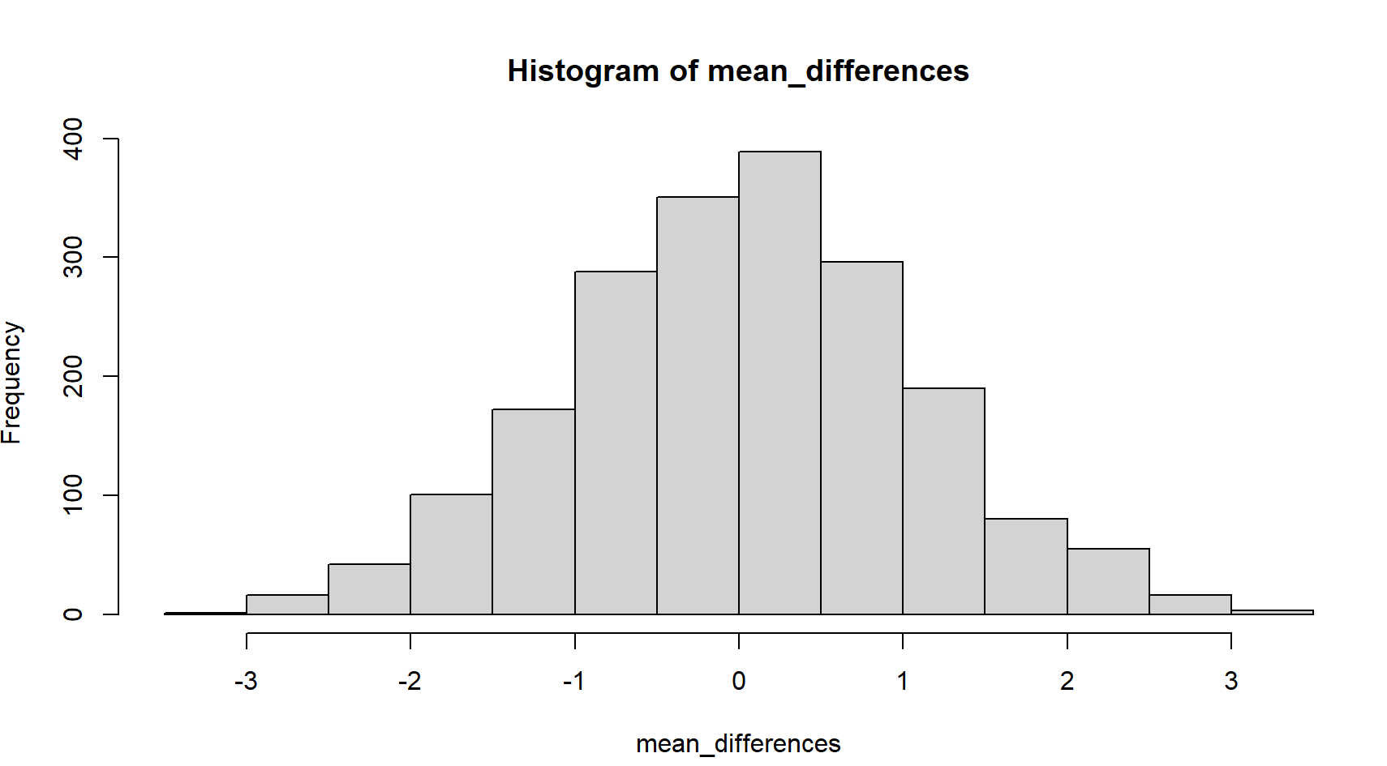
3. n = 2000

mean_differences = c()

for (i in 1:n)

{

mean_differences = c(

mean_differences,

two_group_resample_diff(dat_pen$flipper_length_mm, 68, 152)

)

}

hist(mean_differences)

sum(abs(mean_differences)>5.8)

1. Over 10 million
2. Chart, box and whisker chart

   Description automatically generated
3. agg_means

species bill_length_mm

1 Adelie 38.79139

2 Chinstrap 48.83382

diff_crit

[1] 10.04243

1. p-value < 2.2e-16

The p value is extremely close to zero, meaning the means of the two groups are very different from one another. There is less than one trillionth of one percent of a chance that there is no difference between the means of the two groups.

1. sum(abs(mean_differences) >= diff_crit)

[1] 0

1. Chart, histogram

   Description automatically generated